Introduction

The gender of German nouns can be identified by the [article](https://deutsch.lingolia.com/en/grammar/nouns-and-articles/articles-noun-markers) they take; *der*for masculine, *die*for feminine and *das*for neuter. While native German speakers intuitively know which article to use, it is best for German learners to learn the article together with the noun. Luckily, there are some rules to help you recognise masculine, feminine and neuter nouns in German Grammar.

Study the rules for grammatical gender of German nouns on Lingolia and practise using *der*, *die* and *das* in the exercises.

Example

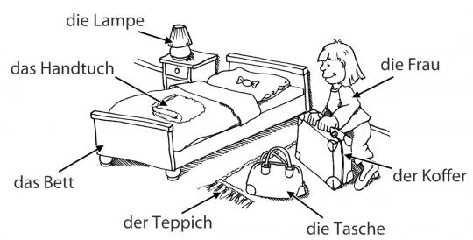

der – Masculine Nouns

This table outlines the rules for the masculine nouns in German.

| feature | example |
| --- | --- |
| male people | der Mann, der Präsident |
| seasons of the year | der Frühling, der Sommer, der Herbst, der Winter (*but:* das Frühjahr) |
| days/months | der Montag, der Dienstag, der Mittwoch, … der Januar, der Februar, der März, der April, … |
| types of precipitation | der Regen, der Schnee, der Hagel, der Schauer |
| nouns that end in *ling* | der Schmetterling, der Lehrling |
| nouns that end in *ich/ig* | der Teppich, der Honig |
| nouns made from verbs *without* *en* | der Lauf (laufen), der Sitz (sitzen) |

die – Feminine Nouns

This table outlines the rules for the feminine nouns in German.

| feature | example |
| --- | --- |
| female people | die Frau, die Präsidentin (*but:*das Fräulein, das Mädchen) |
| numbers used as nouns | die Eins |
| nouns ending in *ung* | die Endung |
| nouns ending in *schaft* | die Mannschaft |
| nouns ending in *ion* | die Diskussion |
| nouns ending in *heit/keit* | die Freiheit, die Heiterkeit |
| nouns ending in *tät* | die Identität |
| nouns ending in *ik* | die Musik |

das – Neuter Nouns

This table outlines the rules for the neuter nouns in German.

| feature | example |
| --- | --- |
| letters of the alphabet | das A |
| nouns ending in *lein/chen* | das Fräulein, das Mädchen |
| nouns ending in *um* | das Museum, das Aquarium |
| nouns ending in *ment* | das Experiment |
| foreign words ending in *ma* | das Thema, das Drama |
| nouns made from verbs in the infinitive | das Laufen, das Essen |
| nouns made from English verbs ending in *ing* | das Timing, das Training |
| nouns made from adjectives that are not referring to something particular | das Neue, das Ganze, das Gleiche (*but:* Das ist der Neue. – *e.g. pupil*) |

Gender of Compound Nouns

When a noun is formed from several other nouns combined into one word, the last noun in the word determines the gender of the entire word.

*Example:* der Tisch + *das* Bein = *das* Tischbein